**Practical Assignment**

**Objective: - Receipt Scanner**

Receipt scanners are used everywhere and they store the contents of the bill or receipts.

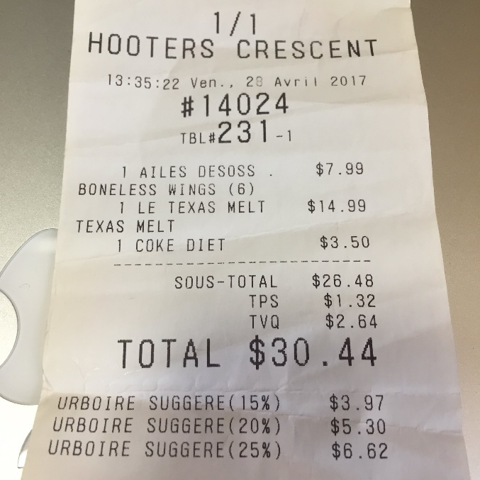

**Dataset Link: -**

Use anyone of your choice.

Ex:- <https://www.kaggle.com/rahulsah06/data-extraction-from-receipt>

**Task: -** Create a Web App where you can user can upload a receipt and get the contents of the receipt.

**Deployment: -** Any Free Platform(Try to look out for free options.)

**Assignment Submission: -** Only submit the hosted app link. OR GitHub Link